Honey, Bake the Roots
Inspired by



DID YOU KNOW?
“Parsnips are the superheroes of vegetables, silently fighting off sickness with their Vitamin C powers and keeping your digestion running smoothly with their fiber sidekicks.!”

Ingredients
1 Vegetable Stock Paste
120g Bulgur Wheat
30g Dried Cranberries
2 carrots
1 parsnip
1 red onion
30g harissa paste
15g honey
75g vegan feta
15g almond flakes
1 tsp butter
1 tbsp olive oil
Nutrition – Total / Per Serving
Calories: 1182kcal / 591kcal
Carbohydrates: 158g / 79g
Protein: 22g / 11g
Fat: 50g / 25g
Fibre: 10g / 5g
Sugar: 40g / 20g






Good for:

Star Rating:





Method


Step 1 – Get Preppin’
Pre-heat the oven to 200°C
Boil the kettle.
Cut the carrots and parsnip into batons (~1cm wide and 5cm long).
Cut the red onion into wedges.
In a bowl, mix the harissa paste, 15g honey, and olive oil.
Season with salt and pepper to taste.

Step 2 – Let’s Roast, Honey
Put the carrots, parsnip, and red onion onto a baking tray.
Drizzle olive oil and season with salt and pepper.
Coat the vegetables and spread into a single layer on the tray.
Put the tray into the oven for ~10 minutes.
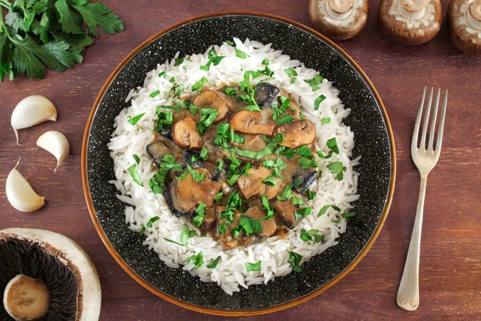
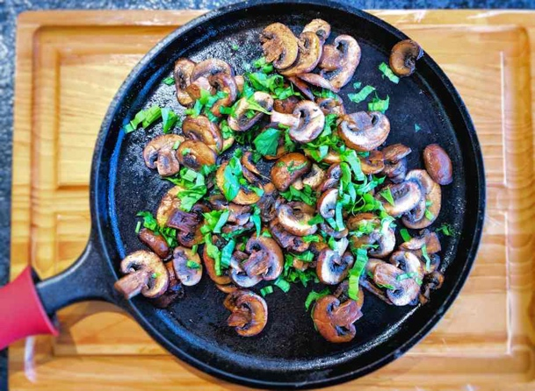
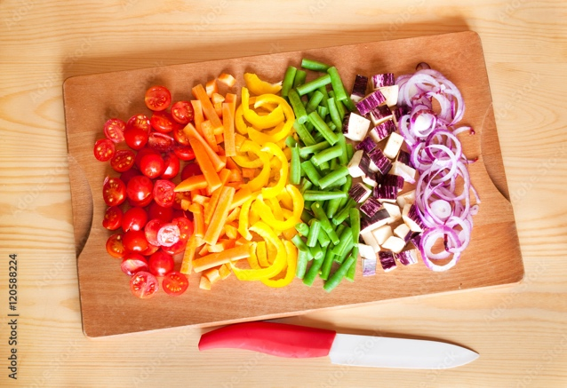
Step 4 – Bring it Together
Once the bulgur wheat has cooked through, stir in the butter, and fluff up with a fork.
Dish up into bowls, place the roasted vegetables on top, drizzle your sauce with the harissa paste, crumble on your feta and finally scatter on some almond flakes.

Enjoy!
Step 3 – Well Bulgur Me Up
Once the water from the kettle has boiled, pour the water into a saucepan together with the stock paste, stir well.
Put in the bulgur wheat and cranberries and bring to a boil again.
Simmer for 1 minute, remove from heat and set aside for ~12-15 minutes.

Turn the vegetables in the oven and place back for another ~7 minutes.
Drizzle 15g honey over the vegetables before placing back in the oven for the last 5 minutes.

